Exercise 5:
Task Management System

1.Understand Linked Lists:

different types of linked lists (Singly Linked List, Doubly Linked List).
Singly Linked List
Think of a singly linked list as a one-way street. In this structure, each individual item is called a "Node," and it holds two specific pieces of information: the actual data you want to store (like a task or an employee record) and a pointer that directs the computer to the exact memory location of the next node in line. Because these connections only point forward, you can only traverse the list in one direction, starting strictly at the beginning (known as the "Head") and moving step-by-step until you reach the very end (known as the "Tail").
Doubly Linked List
A doubly linked list functions more like a two-way street. In this setup, every Node expands to contain three distinct components: the core data, a pointer to the next node, and an additional pointer to the previous node. This structural change gives you the flexibility to traverse both backward and forward seamlessly, which speeds up a variety of operations like deletions or reverse searches. However, the tradeoff is that it requires more memory behind the scenes to store those extra pointers for every single item in the list.

2. Setup:
We will implement this in Java. we will build a Singly Linked List. We will separate our data payload (the Task) from the mechanism that connects them (the Node). Create Task and TaskManager
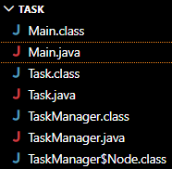

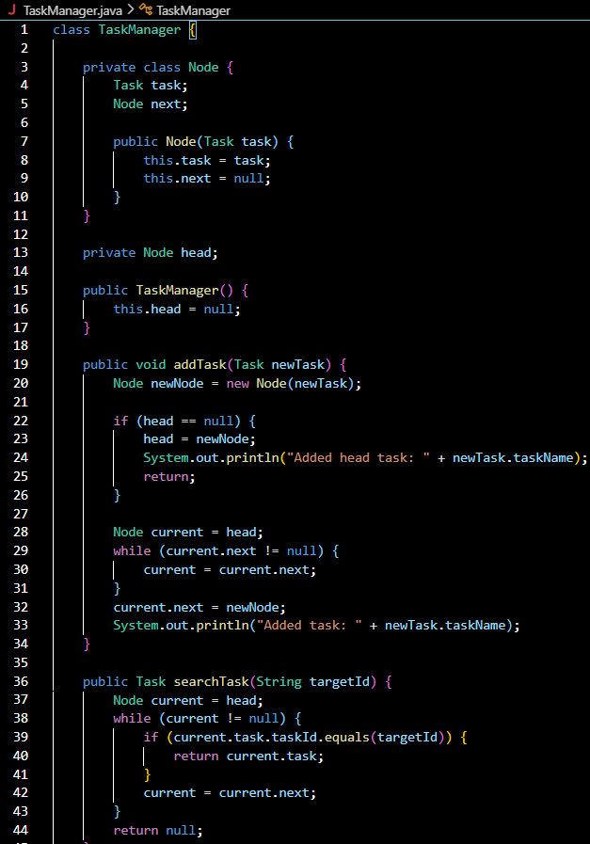
3.Implementation:
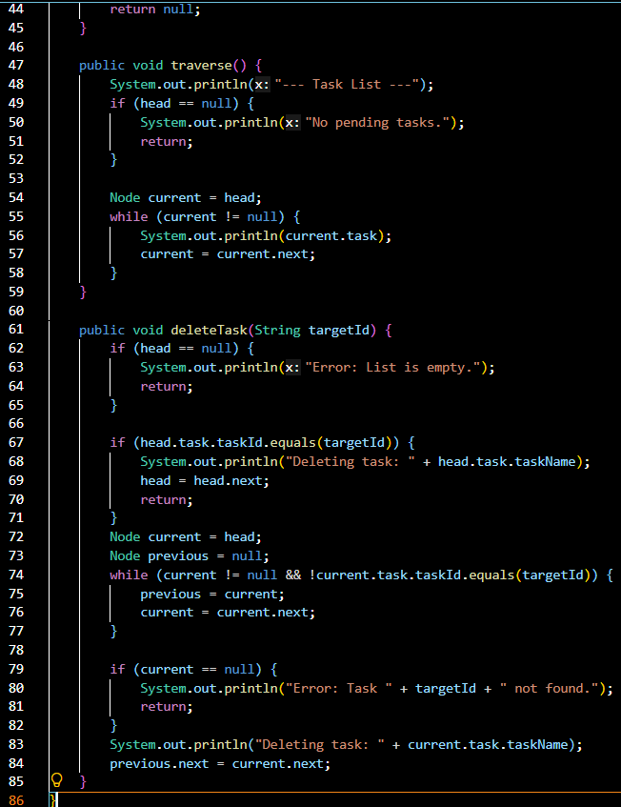
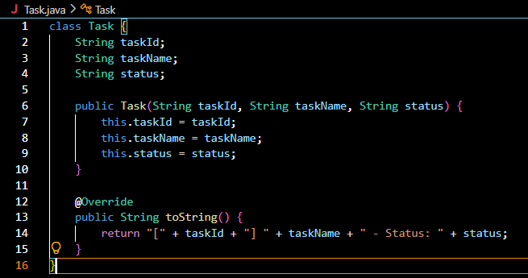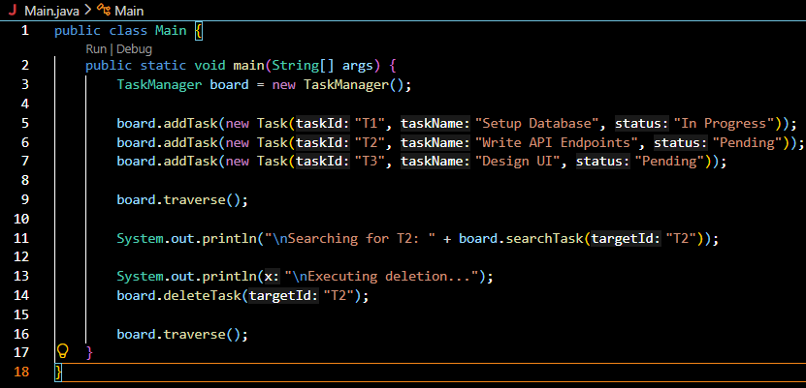
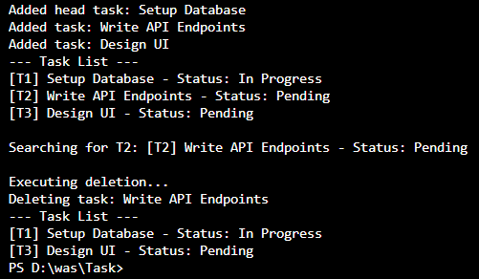

4.Analysis:
Operation | Time Complexity
Add (Append) | O(n)
Search | O(n)
Traverse | O(n)
Delete | O(n)

The Advantages of Linked Lists Over Arrays
- True Dynamic Sizing: With a Linked List, you never have to guess the capacity beforehand. It starts at size 0 and can grow indefinitely until your computer completely runs out of RAM. You never hit an "Array is full" error.
- Lightning Fast Middle Modifications: If you want to insert a high-priority task between Task 1 and Task 2, you just create the node and rewire two pointers. It takes nanoseconds. In an array, inserting an item in the middle forces you to painstakingly shift potentially millions of subsequent items down one slot.
- No Memory Waste: An array of size 100 with only 5 items in it wastes 95 slots of memory. A Linked List of 5 items uses exactly the memory required for 5 items, and nothing more.

